Name: Class:


Task 1
1. Qwerty is a small island in the southern hemisphere.
The Qwertian people have two types of people. The ASCIIs who always say the truth and the UNICODEs who always lie.
There are three people (A, B and C) in a Qwertian coffee shop.

You know from a friend that A is an ASCII, but they will never tell you directly if someone is or isn’t a UNICODE for fear of being attacked.
Write an algorithm for questions that you could ask A, B and C that would determine whether B and C are ASCIIs or UNICODEs.

2. You have a 3 litre jug and a 5 litre jug.
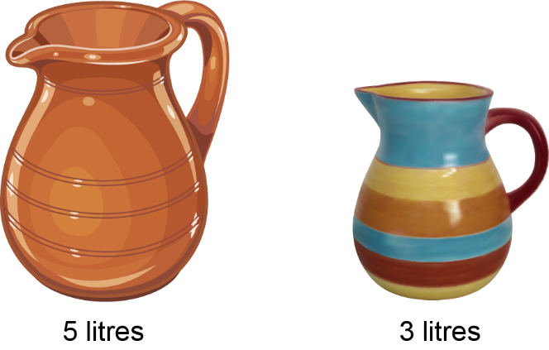
You need to fill the 5 litre jug with exactly 4 litres of water.
Write an algorithm to solve this problem

3. Noughts and crosses is a game played with a 3x3 grid.
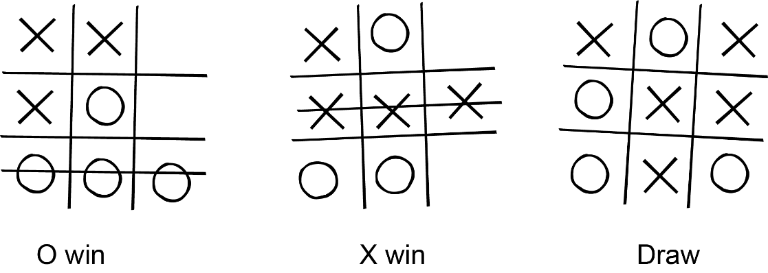
Two players take turns to add an X or O to the board
If a player gets three of their symbols in a row they win the game.
If no player achieves this, then the game is a draw.
(a) Create an algorithm for a computer to play a game of noughts and crosses against a human. The computer will be X.

(b) Now try your algorithm against a partner’s.
Which algorithm is better at playing the game?

Task 2
1. “Beetle” is a dice game for two or more players, played with a single six-sided die.
The objective is to be the first to draw all parts of a beetle. At each turn, a player rolls the die to decide which part can be drawn.
The body has to be drawn first, by throwing a 6. Head, legs and tail can then be drawn when the correct value is shown on the die.
Eyes and antennae cannot be drawn until the head is drawn.
The first person to draw all the body parts is the winner.
Throw | Part | Count
Six | Body | 1
Five | Head | 1
Four | Tail | 1
Three | Leg | 4
Two | Antenna | 2
One | Eye | 2
You need to write a program to allow a player to play Beetle against the computer.
(a) Decompose this game into component parts using a structure diagram.

(b) Which sub-sections, if any, could be reused if you are asked to write a program for a different dice game?

Task 3
Find an Internet site that simulates playing a simple dice game, and decompose the steps in the algorithm used to program the game.
Briefly describe the rules of the game
- What is displayed on the initial screen? What happens next?
- What is displayed once the game starts?
- What steps does the algorithm perform on each roll of the die?
- What is displayed when the game ends?
e.g. http://www.playonlinedicegames.com/
Draw a structure diagram which shows how the game is decomposed.

