Name: Class:

Task 1
Social media is used widely in society.
(a) List five examples of social media.

(b) Your teacher will divide the class into two groups.
Group A – Research the benefits of using social media. Concentrate on any ethical or cultural benefits that you can find.
Group B – Research some concerns or disadvantages of using social media. Concentrate on any ethical or cultural concerns or disadvantages that you can find.

(c) Discuss the findings of your research with the class.
Task 2
In the exam, you will typically be given a longer question asking you to discuss the impact of a digital technology from ethical, cultural or environmental angles.
An example question could be:
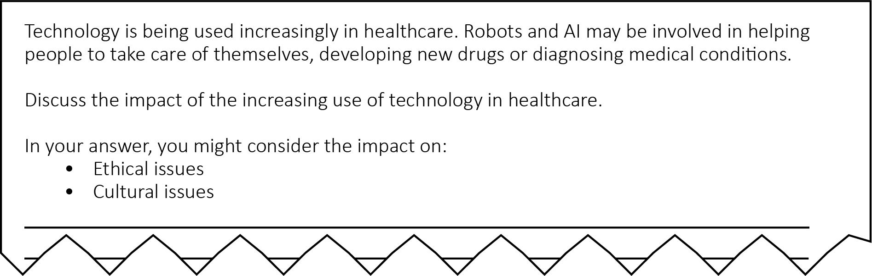
These questions will typically be 8 marks.
For each of the following questions, use the Internet to help make your answers as full as possible.
(a) You will need to show that you have ‘a thorough knowledge and understanding of a wide range of considerations’.
Before starting to answer such a long question, it is advisable to plan your answer.
Using the Internet to help, list three areas of healthcare where robots or AI are being used.
Area 1:

Area 2:

Area 3:

It is important when answering longer questions that your answer applies to the context of the question and that any examples are relevant.
(b) What is the context in the example question?

(c) For each of the areas that you gave in part (a), check that they are relevant to the context of the question. If they are not then change them to something more relevant.
Add any examples that you can think of or have found to each area you gave in (a).

Now you need to consider the impacts of increasing use of technology in healthcare on ethical and cultural issues.
You must ‘weigh up both sides of the discussion’.
(d) For the areas that you listed in part (a), list as many benefits of using technology as possible. Remember that in this question these should consider cultural or ethical benefits.

(e) For the areas that you listed in part (a), list as many concerns of using technology as possible. Remember that in this question these should consider cultural or ethical benefits.

(f) Write down four tips to help you when writing extended answers as given in this question.
Tip 1:

Tip 2:

Tip 3:

Tip 4:

Task 3
The ‘digital divide’ refers to the difference between those who have access to computers and the Internet and those who do not.
(a) Visit https://www.cable.co.uk/broadband/speed/worldwide-speed-league/
Choose two countries that have a large difference in their broadband access. Record the differences here:
Country 1:

Country 2:

(b) For the countries that you chose in part (a), what is the cultural impact of having slower or faster Internet on a country and its population?

