Name: Class:

Task 1

Fill in the name of the utility program being described in each row below:

|  |  |
| --- | --- |
|  | Prevents malware being installed and important files being changed or deleted. |
|  | Helps to find temporary files that are no longer needed and can be deleted to free up space |
|  | Packages a file so that it has a reduced file size. |
|  | Optimises the use of the hard disk space by collecting together the separate parts of each file in one location on the disk. |
|  | Takes a file and encodes it in such a way that it cannot be decoded without a key or password |

**Task 2**

The grid below represents locations (sectors) on a hard disk where files can be stored. Each one is 512 bytes, so a file will occupy several sectors.

**The task:**

Follow these steps to simulate the storage of some files on a disk. Do this by labelling the sectors below (the squares) with the file ID number. There are already some files on the disk (grey squares).

1. File 6 needs 8 sectors of disk space, write it to the disk

2. File 7 needs 11 sectors of disk space, write it to the disk

|  |  |  |  |  |  |  |  |  |  |  |
| --- | --- | --- | --- | --- | --- | --- | --- | --- | --- | --- |
| 6 | 6 | 1 | 1 | 1 | 1 | 1 | 1 | 2 | 2 | 2 |
| 2 | 2 | 2 | 2 | 2 |  |  |  | 3 | 3 | 3 |
| 3 | 3 | 3 | 3 | 3 | 3 | 3 | 3 | 3 | 3 | 3 |
|  |  |  |  | 4 | 4 | 4 | 4 | 4 | 4 | 4 |
| 5 | 5 | 5 | 5 | 5 | 5 | 5 |  |  |  |  |
|  |  |  |  |  |  |  |  |  |  |  |

3. What did you have to do to fit the last file onto the disk?

4. Why does this make it slower to read this file?

5. What does the disk defragmenter do?

6. Show what the disk will look like after the disk defragmenter has run.

|  |  |  |  |  |  |  |  |  |  |  |
| --- | --- | --- | --- | --- | --- | --- | --- | --- | --- | --- |
|  |  |  |  |  |  |  |  |  |  |  |
|  |  |  |  |  |  |  |  |  |  |  |
|  |  |  |  |  |  |  |  |  |  |  |
|  |  |  |  |  |  |  |  |  |  |  |
|  |  |  |  |  |  |  |  |  |  |  |
|  |  |  |  |  |  |  |  |  |  |  |

Task 3

You can find out how much space there is on a disk drive in **Windows Explorer**.

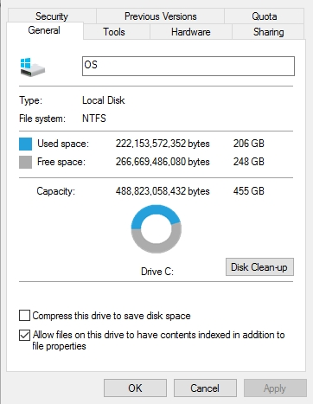

Right-click on the drive name and select **Properties**.

If you use macOS then open a **Finder** window and select the storage device on the left. Click the **File** menu and select **Get Info**.

1. How much space is there on the hard drive on your computer?

2. Will defragmenting the disk give you more space? Explain your answer.

3. Should you defragment an SSD?

4. How do you defrag a hard drive?