Name: Class:

Task 1

1. What does an operating system do?

Write down what you think an operating system does. Use screen shots from an operating system that you use to illustrate your points.

*Here are some examples of the type of screen shots you could use.*

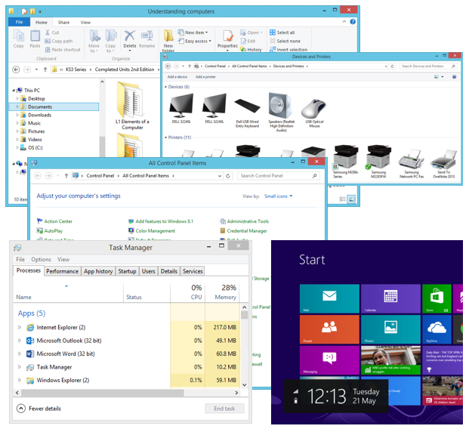

Task 2

1. What type of user interface does a smartphone have?

2. List three differences between a mobile phone and a desktop PC that affect how the user interface operates.

3. An advanced computer user makes use of a command line interface.

They enter the commands below which are in green.

The commands are:

* ls – which lists all the files
* rm *.py – which removes all python files
* ls – which lists the files that remain

~$ ls

~$ program1.py program2.py program3.py   
 help.txt important.txt

~$ rm *.py

~$ ls

~$ help.txt important.txt

(a) Write down all the steps that would be required to delete all python files from a folder using an operating system with a graphical user interface. Make sure to include every time that the mouse is moved, a button is clicked or a keyboard button is pressed.

(b) Why would an advanced user prefer to use a command line interface?

(c) Why do most users in the world use GUIs rather than command line interfaces?

Task 3

1. One task that an operating system carries out is memory management.

Using as many of the following key words as you can, explain how memory management works. You may wish to research memory management before you start answering this question.

|  |  |  |
| --- | --- | --- |
| Memory management | RAM | Virtual memory |
| Secondary storage | Open a program | Loading |
| Free area of RAM | Out of memory error | swapping |
| Memory protection |  |  |

2. User management is almost always used on school and business computers.

Give at least five ways that user management is used on your school’s network.