Name: Class: Mark:

1. Computer software that harms computers, networks or data is known as malware.
Describe two different types of malware that exist. [6]
Malware example 1

Malware example 2

Malware example 3

2. Study the email on the following page
State three reasons which indicate that it is a phishing scam. [3]
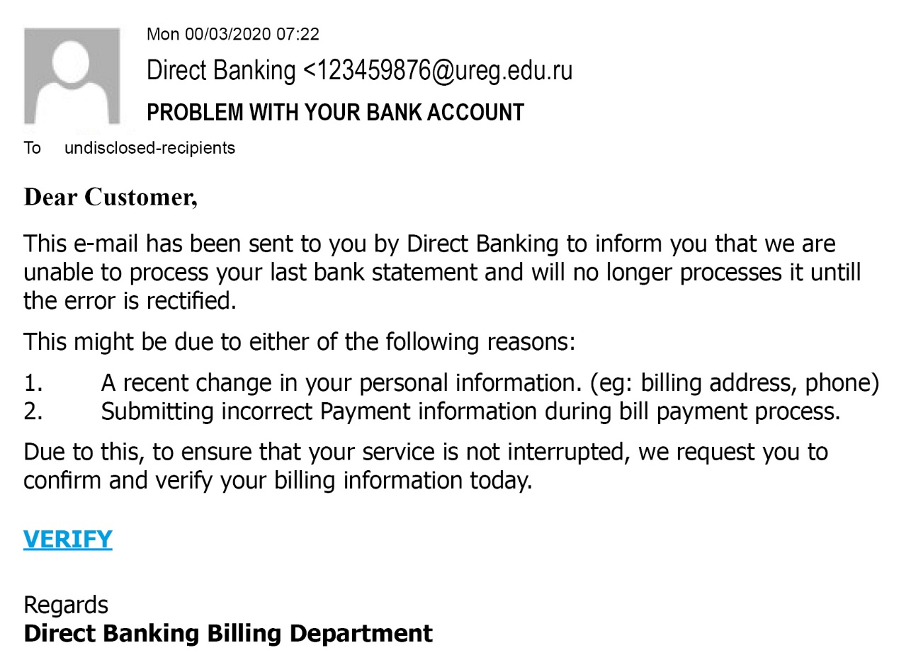

3. (a) Describe what is meant by a denial of service attack. [2]

(b) Indicate in the right-hand column whether each of the following statements about a denial of service attack is true or false. [4]
True or False
It aims to block an individual’s email account
The aim of the attack is spread misinformation about an organisation
The motive is often blackmail or revenge
It may cause the victim’s network to crash

[Total 15 marks]

