Name: Class:

Task 1
1. The performance of a CPU is dictated and dependent on a number of factors. Complete the table below, stating how each of the factors mentioned affects the performance of a CPU.
Factor | How this affects performance
Clock speed
Cache Size
Number of cores

2. Two computers have different specifications.
Computer A has a quad core processor with a frequency of 2GHz.
Computer B has a dual core processor with a frequency of 4GHz.
(a) What is the maximum number of fetch-execute cycles that each processor could achieve?

(b) Explain why choosing processor B may be the better choice.

(c) Discuss how the use of cache can improve the performance of CPUs.

Task 2
1. Below are three devices that use embedded systems. Complete the table below the pictures and state how these devices use embedded systems
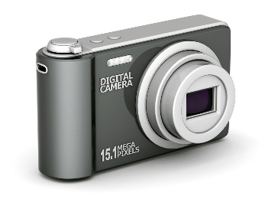
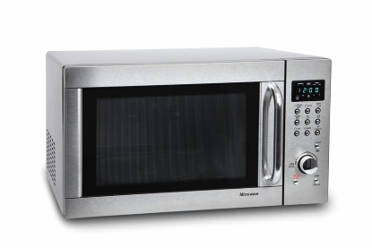
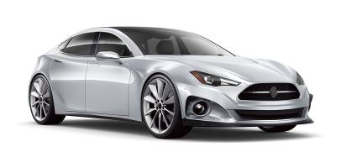

2. Research other embedded systems that are used today.
List as many as you can below.

